It’s Getting Ugly in Hungary
Desperate to shore up his flagging popularity, Viktor Orbán is embracing the far right.
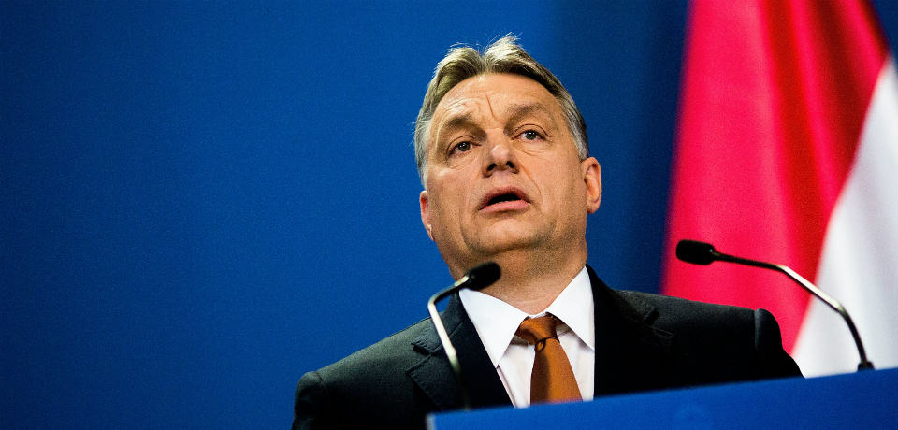
Hungary’s Prime Minister Viktor Orbán, who notoriously declared in the summer of 2014 that his party was going “to build an illiberal nation state,” is garnering criticism again. This time, liberal politicians and human rights NGOs are calling him out for his extreme anti-immigrant stance and talk of returning the death penalty.
On April 28, following a murder in a tobacco shop in the south-western city of Kaposvár, Orbán argued for “keeping the issue of the death penalty on the agenda,” noting that the deterrent effect of other measures has proved insufficient. Hungary abolished capital punishment in 1990 after the fall of communism, and the reintroduction of this extreme measure would conflict with the basic principles of the EU, which Hungary joined in 2004. Rebecca Harms, co-president of the Green party grouping in the European Parliament, noted that
Moreover, while EU leaders were preparing for emergency talks in Brussels after about 900 African migrants drowned in the Mediterranean just outside Libyan waters, Orbán’s government was launching “a national consultation” on immigration. This month, the government is preparing to mail Hungarian citizens 8 million questionnaires containing 12 questions about immigration. Though framed as a consultative, democratic process, a closer look shows that the true intent of the questionnaire is to vilify Hungary’s immigrants, fan xenophobic sentiment, and promote harsh anti-immigrant measures.
The questionnaire begins by raising largely imaginary concerns about terrorism in Hungary and immediately asks: “Do you agree that mistaken immigration policies contribute to the spread of terrorism?” It reveals the government’s stark Euroskepticism in alleging that the EU’s “policies on immigration and terrorism” have failed, while implicitly asking Hungarians to support new, “stricter immigration regulations in opposition to Brussels.” The questionnaire also refers to “the Hungarian people” (magyar emberek) rather than “Hungarian citizens” (magyar állampolgárok), thus framing the immigration issue in ethnic terms and appealing to xenophobic sentiment. The “stricter immigration regulations” it mentions could involve, as it implies, building “internment camps” where illegal immigrants would be held before they were returned “to their own countries.”
It is hardly surprising that Louis Michel, Belgium’s former Minister of Foreign Affairs, commented in response that “this stigma that systematically links the migrant with a criminal can only come from a far-right populism where xenophobia is at the very root of ideology.” Indeed, in the European context, calls for reintroducing capital punishment, Euroskepticism, ethnic nationalism, and harsh anti-immigration rhetoric are usually associated with far-right parties. The question now being raised is whether Orbán has effectively joined the far right, thus making Hungary the first EU country to be ruled by a far-right government. Add to this Orbán’s earlier statements about “illiberal democracy” as a model of governance, and the question appears even more justified — and troubling.
Some commentators argue that Orbán “likes to dislike Brussels,” implying that his Euroskepticism is a means to gain leverage in negotiations with the EU. Yet the policies and practices of Orbán’s government cannot be dismissed merely as an expedient tactic. Democracy is indeed declining in Hungary as registered, in particular, by the Economist Intelligence Unit. Since Orbán’s party, Fidesz, returned to power in 2010, he has modified electoral laws to its benefit, taken control of the judiciary, appealed to ultranationalism as a source of political cohesion, and undermined media freedom.
If Orbán has indeed become a far-right leader, this would be an easy explanation for developments in Hungary, but the situation may be more nuanced. The major problem Orbán currently faces is that Fidesz is — despite his best efforts — losing popularity. At the end of 2014, public opinion polls registered a 12 percent drop in support for the party, and its rating continued to slide into 2015. This is not simply a problem for Fidesz; rather, it is a personal problem for Orbán, who needs to maintain his leadership of a party in which other high-ranking members may be associating its decline with Orbán himself.
Polls have shown that Fidesz has most likely been losing votes to the even more right-wing Jobbik party and the Hungarian Socialist Party. Partly because of Fidesz’s decline and partly due to Jobbik’s successful strategy of deradicalization, Orbán’s party has lost to Jobbik in a recent by-election that has become a historic moment for the far right: it has become Jobbik’s first ever individual constituency seat in parliament.
Orbán’s far-right rhetoric may be an attempt to recover right-wing support his party has been losing to Jobbik. The apparent moderation of Jobbik has opened a vast ideological area further to the right that Fidesz can now venture upon. Curiously, however, only 1 percent of the Hungarian population is concerned about terrorism and only 3 percent are worried about immigration, according to Eurobarometer surveys. Both of these percentages are below European averages. Therefore, Orbán may be unable to deploy Jobbik’s far-right card in full measure. Moreover, Fidesz is blocked from using Jobbik’s most successful issue, that of populism: Fidesz is unable to claim that it is defending “ordinary people” against the “elites,” because Fidesz is the ruling elite.
What the Hungarian public is genuinely concerned about is unemployment (50 percent), the economy (30 percent), and health and social security (21 percent). Orbán’s government bears full responsibility for unpopular policies in these areas. Since Orbán cannot admit his own failures, he needs a scapegoat, and his harsh Euroskeptic rhetoric indicates that he has chosen Brussels. But Orbán will need to try hard to convince Hungarians that their country’s domestic problems are Brussels’ fault: Hungarians’ trust towards the EU is higher than the EU average.
It seems that pressure on Orbán’s government will be increasing. Fidesz has not provided any good answers to growing social concerns, apart from turning to Euroskepticism and right-wing populism that the party can’t even fully employ. It’s possible that, in desperation,
Orbán may continue to degrade democracy in Hungary by going further down the Russian path. For this reason, the EU should closely follow Hungarian developments and remember that Article 2 of the Treaty on the European Union clearly states that “the Union is founded on the values of respect for human dignity, freedom, democracy, equality, the rule of law and respect for human rights, including the rights of persons belonging to minorities.” The Treaty on the European Union also provides a basis to counter tendencies that are in violation of the above-mentioned values, including suspending member countries’ voting rights in the Council. If Orbán continues to be tempted to restore his popularity through increasingly non-democratic measures, the EU will find itself obliged to do just that.
Photo Credit: Carsten Koall/Getty Images

