The sex school breaking taboos in Kyrgyzstan
Teaching people to be confident about intercourse is vital, says founder, whose classes have been so successful she is expanding into neighbouring Kazakhstan.

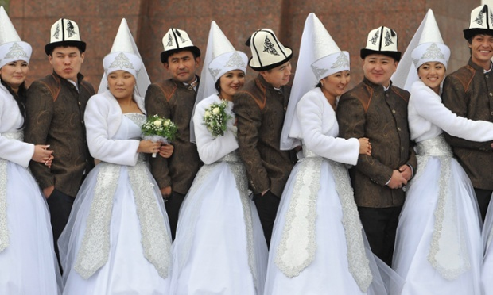
Kyrgyz couples take part in a mass wedding ceremony in the capital Bishkek. The Jade Gift school aims to break taboos around sex in the former Soviet republic. Photograph: Vyacheslav Oseledko/AFP/Getty Images
When Rakhat Kenjebek kyzy opened Kyrgystan’s first sex school three years ago, she wasn’t sure how it would be received. The topic had been taboo since the days of the Soviet Union, and everyone was sceptical about whether her business would survive.
But these days the Jade Gift school, which offers courses on sexual fantasy and “playing the flute” – a metaphor for oral sex, has more than 150 students between the ages of 18 and 66. It has proved so popular that it is moving to bigger premises and has opened a branch in neighbouring Kazakhstan.
“I never expected this to become a full-time job,” said 31-year-old Kenjebek kyzy.
After the fall of the Soviet Union, sex hit Kyrgyzstan like a hammer
“I wanted to create a place where women can develop their femininity. [In the Soviet Union] women had to function like robots. Today they need to wake up from their post-Soviet stupor,” she adds..

Experimenting
In Kyrgyzstan, talking about sexuality is still discouraged and many young people are confused about sex. This leads to all sorts of problems, says Bubusara Ryskulova, director of the country’s only women’s crisis centre.
“After the fall of the Soviet Union, sex hit Kyrgyzstan like a hammer. People were not ready,” she says. “Girls were experimenting and wore provocative fashions. This was interpreted the wrong way.”
With foreign donor support the centre, called Sezim, has helped more than 3,000 women a year since 1998: with 60% percent fleeing domestic abuse and others facing trafficking and bride kidnapping.
A lack of awareness about sex contributes to the abuse, Ryskulova says. “If a couple is not educated in sex this can lead to unpleasant experiences,” she says. “Sex might not be the main cause of a bad relationship but often it is an underlying problem that can make big waves, and can even lead to domestic violence.”
Kenjebek kyzy says many of her students are girls from religious families who attend classes because they are afraid their husbands will take second wives. Polygamy, though illegal, is increasingly common in Kyrgyzstan.
“There is a passage in the Hadith, the teachings of the Prophet, that says women should be good wives, meaning they should be sexually educated. This is what we do,” said Kenjebek kyzy, who also grew up in an observant Muslim household.
In Ryskulova’s opinion, sex education is sorely needed in Kyrgyzstan and she cautiously supports the Jade Gift School.
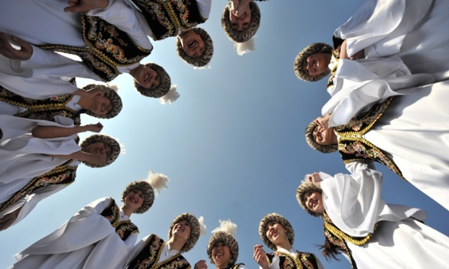
The school now employs three sales managers, a social media manager and five trainers. Photograph: Vyacheslav Oseledko/AFP/Getty Images

Bodybuilder
But there’s more than just sex ed at Jade Gift, which helps explain its success. Besides the regular gymnastics classes (which cost about £22 a month and are advertised on social networking sites), the school offers one-time classes in “partner massage” and “sexual fantasy”. The courses, says Kenjebek kyzy, help women learn to enjoy and respect themselves.
We combine ancient methods based on the Chinese Tao of love or the Japanese art of the geisha with modern concepts
The school also caters for men. In a culture with rigidly defined roles, men can also face extra pressure, says Kenjebek kyzy.
Recently, it established a “Men’s power class” taught by former bodybuilder and fitness coach Alexander Novitsky. “Like in the female class, we want to strengthen the muscles used during sex,” said Novitsky, who also teaches his students techniques to avoid prostate cancer and gives tips on how to please women.
The school now employs three sales managers, a social media manager and five trainers.
With a growing client base, finding enough qualified staff is tough. “It takes a year to instruct a trainer because our teachings are a new thing. We combine ancient methods based on the Chinese Tao of love or the Japanese art of the geisha with modern concepts, as well as our own ideas,” she says.

