Kyrgyzstan Bans IS, Designates It As Terror Group
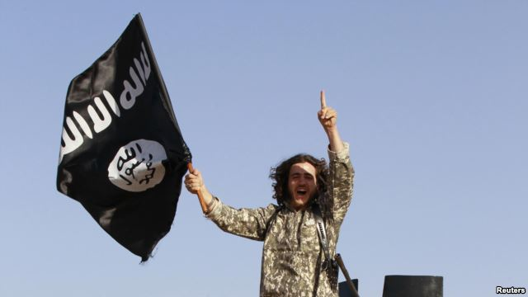
The Osh prosecutor's office has reportedly found that four groups "are involved in the recruitment of Kyrgyz citizens and the transfer of recruits to the Syria-Iraq zone for participation in hostilities in the ranks of terrorist organizations. (file photo)
March 25, 2015
Kyrgyzstan has designated the Islamic State (IS) group as a terrorist organization, and banned its activity in the republic, the Kyrgyz intelligence agency, the State Committee for National Security (GKNB) has announced.
"The national security agencies and the prosecutor-general's office have, within the framework of guarding against and preventing extremism and terrorism, on the basis of materials collected, implemented a suit in the court system to recognize the IS organization as a terrorist and extremist [group]," the GKNB said in a statement.
The GNKB said that, by decree of the Oktyabrsky District Court in Bishkek, all activities of the Islamic State group in Kyrgyzstan are prohibited.
The statement said that the Oktyabrsky court had ruled on February 13 to recognize IS as a terrorist and extremist group, and that the order had entered into force on March 16.
On March 5, the Osh district prosecutor's office filed a request with the Osh City Court to rule that a number of organizations, including the IS group, are terrorist groups.
The list filed with the Osh court include groups in which Central Asian militants are known to be fighting. They are Al-Qaeda's Syria affiliate, Jabhat Al-Nusra, the ethnic Uzbek groups Katibat Imam Al-Bukhari and Jannat Oshiklari, and the IS group.
The Katibat Imam Bukhari pledged allegiance to Afghan Taliban leader Mullah Omar in November 2014, while Jannat Oshiklari (also known as Tawhid Wal Jihod) is an independent faction. Both fight alongside Jabhat Al-Nusra in Aleppo province, though they are not formally part of that group.
According to the Interfax news agency, the Osh prosecutor's office said it had found that the four groups listed in the request to the court "are involved in the recruitment of Kyrgyz citizens and the transfer of recruits to the Syria-Iraq zone for participation in hostilities in the ranks of terrorist organizations, so that later they can return home and conduct illegal activities here."
It is notable that two of the non-IS groups on the Osh prosecutor's list -- Tawhid Wal Jihod and Katibat Imam Bukhari -- are comprised mainly of ethnic Uzbeks, while Jabhat Al-Nusra has a Russian-speaking faction that is led by an ethnic Uzbek. The GKNB this month claimed that the majority of Kyrgyz nationals fighting in Syria are ethnic Uzbeks.
The announcement by the GNKB that it was prohibiting IS activity came as the Kyrgyz intelligence agency also announced that a group of three Tajik citizens had been arrested in an airport in Osh on March 22 as they tried to travel to Syria to join IS militants.
The three Tajiks were attempting to fly to Istanbul in Turkey and were accompanied by young children, according to the GKNB, as reported by Interfax.
"By their own admission, they were recruited by an individual in the Syria-Iraq zone and who invited them via a social network to join the ranks of the Islamic State [group]," the GKNB said.
-- Joanna Paraszczuk

Source: http://www.rferl.org/content/kyrgyzstan-bans-islamic-state/26920328.html

